Lesson 05 Demo 02

Creating Network Security Group

Objective: To create a network security group for controlling inbound and outbound traffic
Tools Required: Azure account with administrator access

Prerequisites: None

Steps to be followed:
- Create a network security group in the portal
- Create inbound rules

Step 1: Create a network security group in the portal

- Log in to the Azure portal, search Network security groups, and click on Network security groups

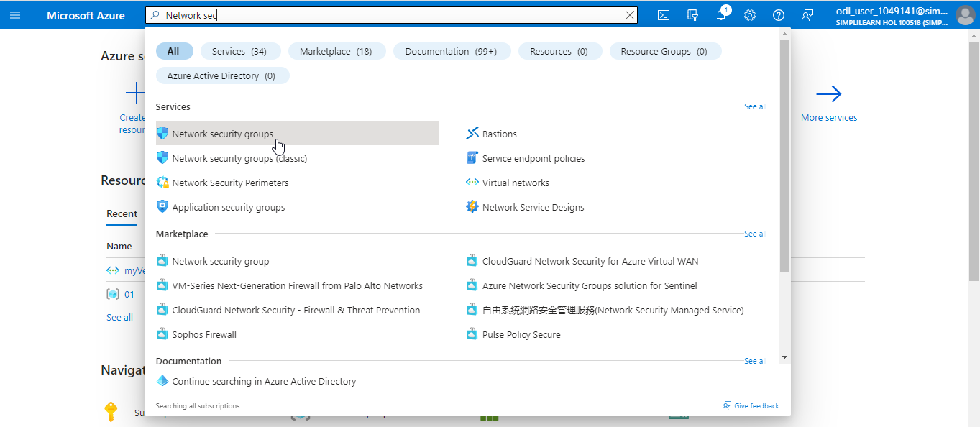

- In the Basics tab, provide the following details:
Subscription: Select the subscription; Resource group: Select new or choose an existing resource group; Name: Select a unique name; and Location: Select the location and then click on Review + create> Create

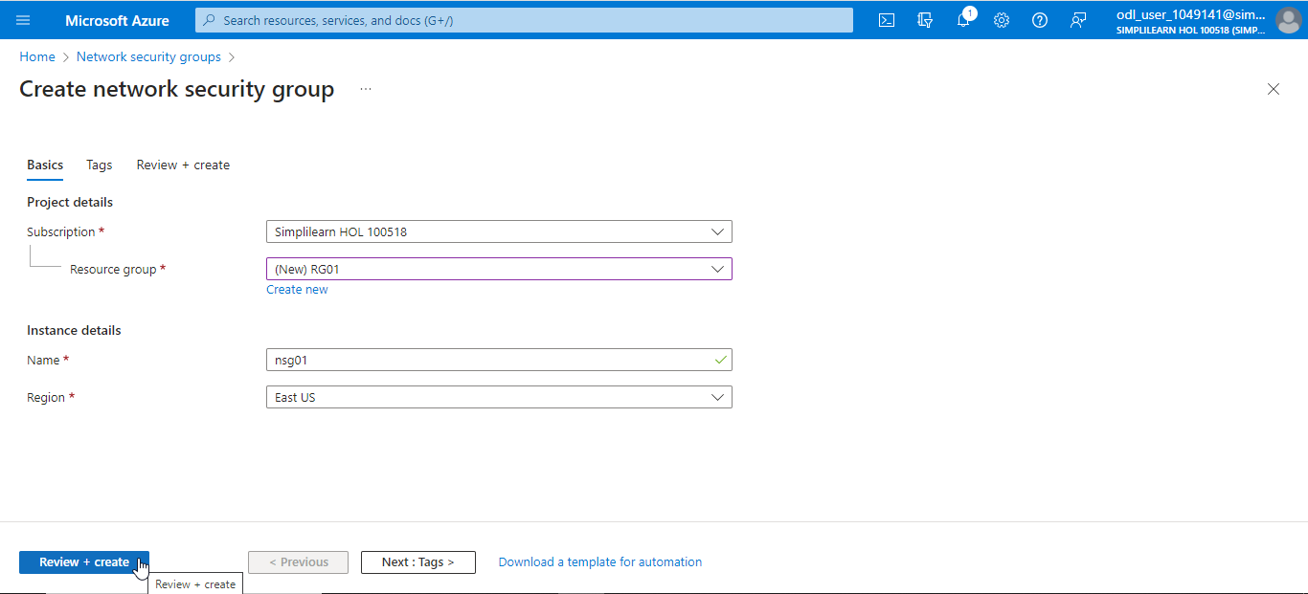

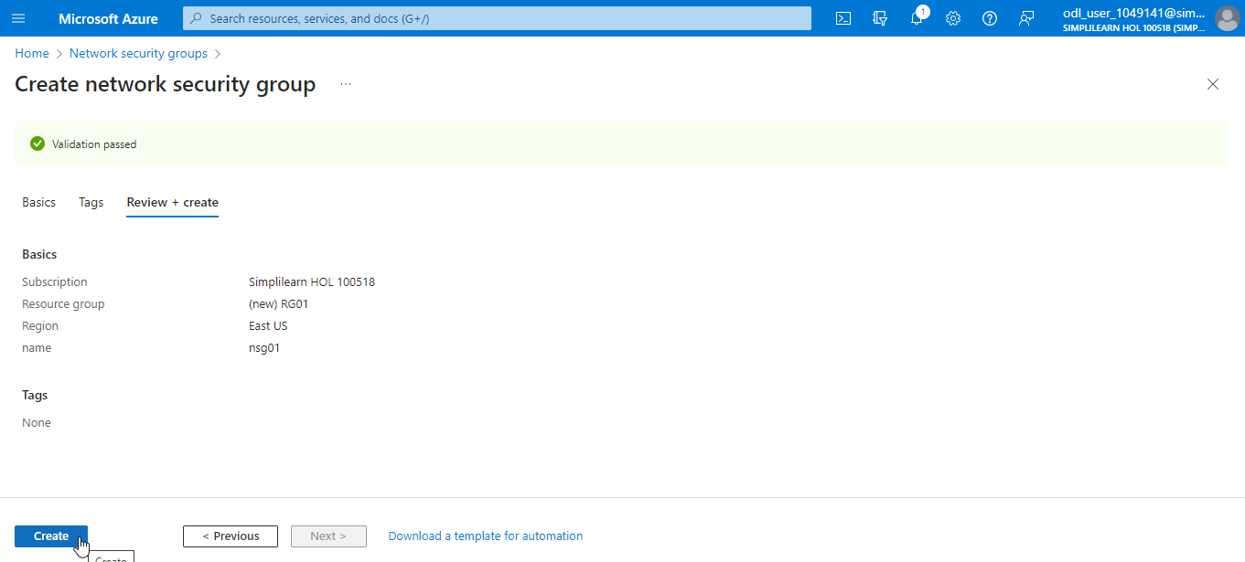

Step 2: Create inbound rules

  - Select the recently created network security group, and take note of the existence of three inbound and three outbound NSG rules

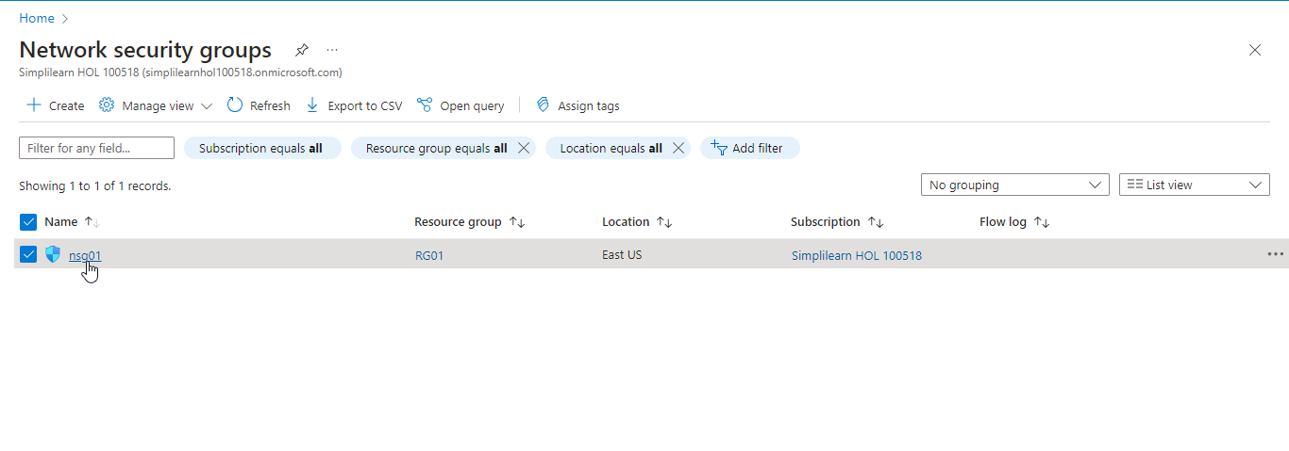

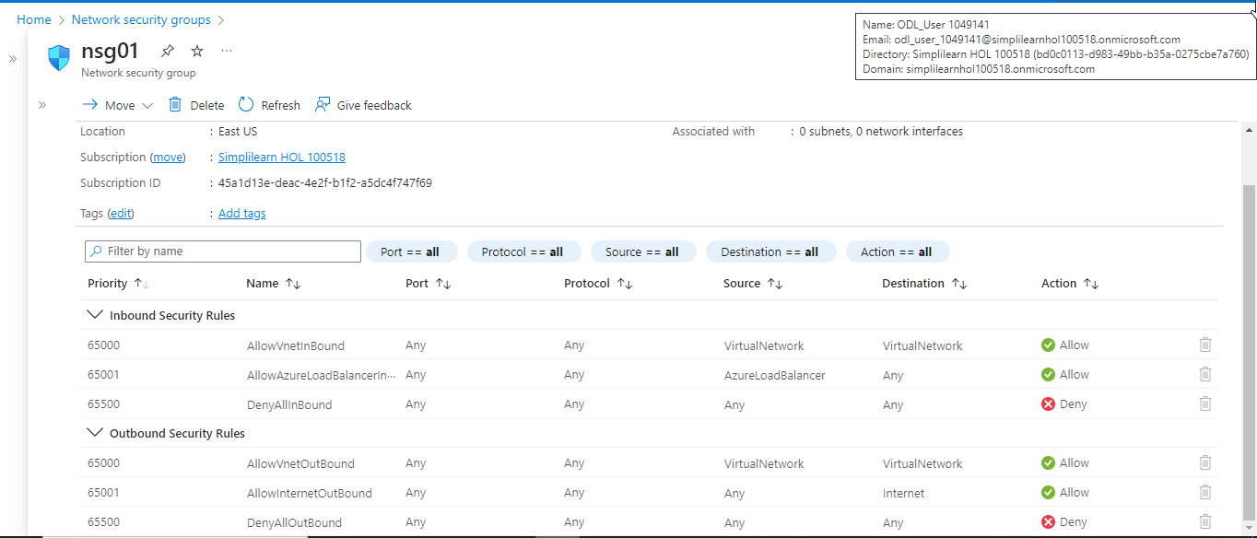

  - In the Settings menu, choose the Inbound security rules. Next, click on Add to create a new inbound security rule. Once the user has configured the rule under Add inbound security rule, click Add to confirm

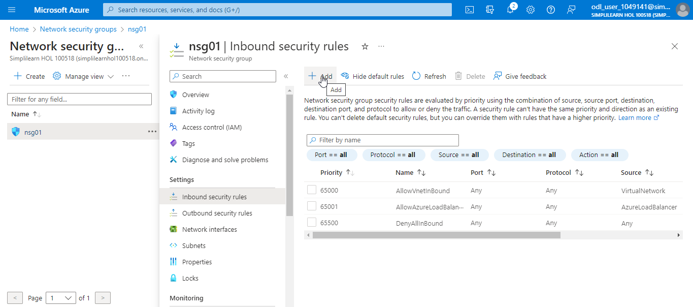

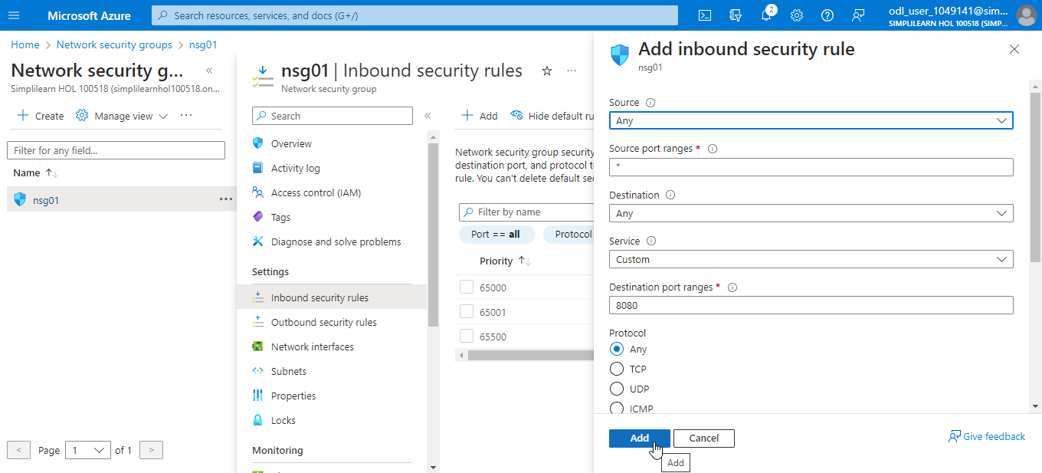

Note: When the user selects a service (such as HTTPS), the port range for example 443 is automatically filled in. This simplifies the configuration of the rule

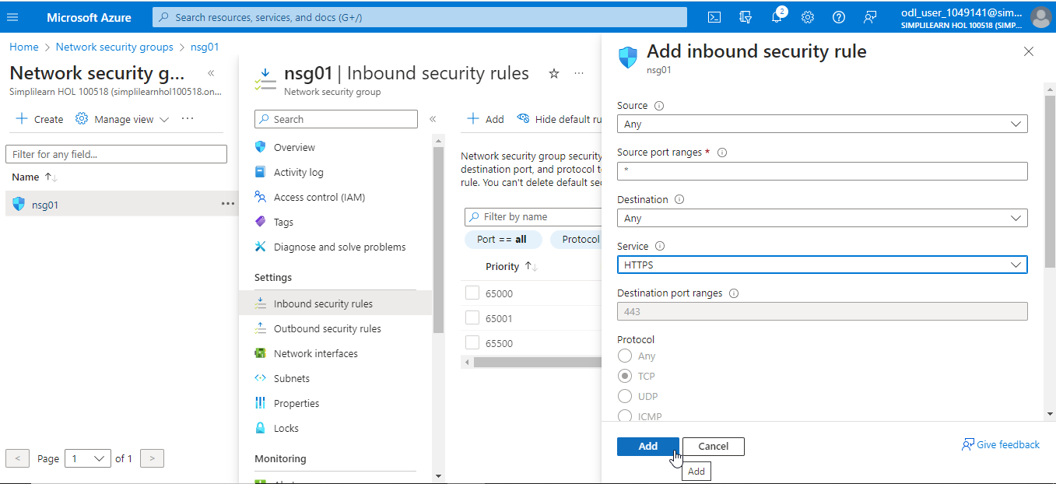

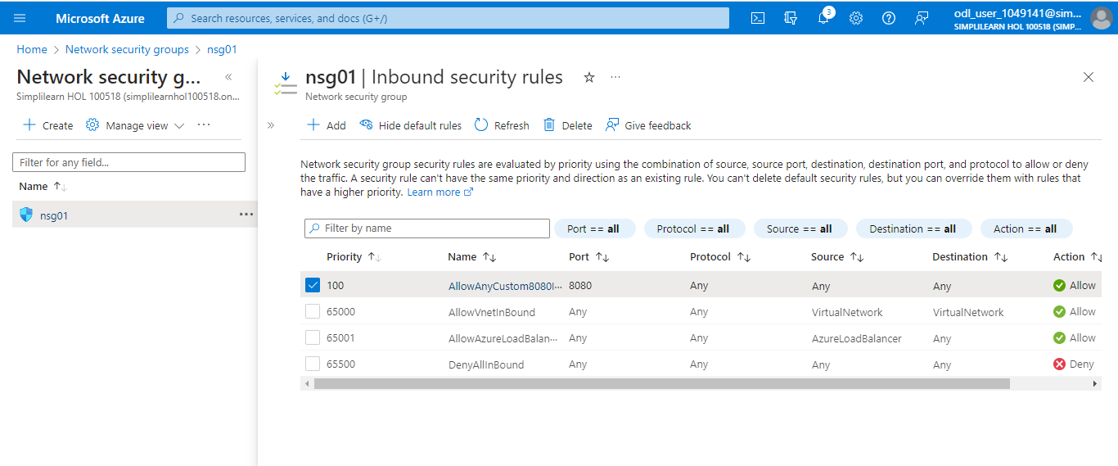

You have now successfully created the network security group rule to have more control over inbound and outbound traffic.

